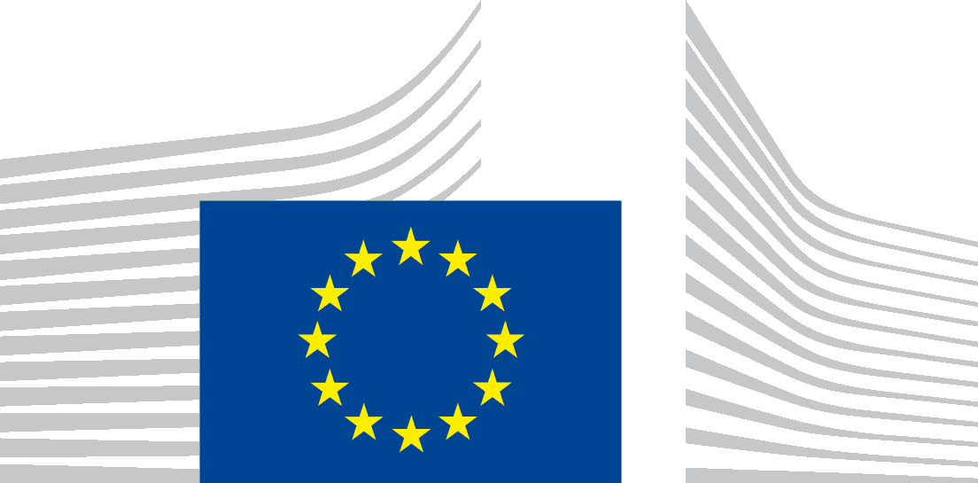 | EUROPEAN COMMISSION  EMPLOYMENT, SOCIAL AFFAIRS AND INCLUSION DG  Europe 2020: Employment Policies  Sectorial Employment challenges, Youth Employment and Entrepreneurship

Brussels,
C2/MF (2013)
Mr / Ms ,

Subject: Invitation to a High-Level Capacity Building Seminar on “DEVELOPING INCLUSIVE ENTREPRENEURSHIP STRATEGIES”

Dear Mr / Ms ,

I am pleased to invite you to a High-Level Capacity Building Seminar on 27-28 June 2013, in Brussels, jointly organised by the Organisation for Economic Co-operation and Development (OECD) and the European Commission. The seminar starts at 08h30 on 27 June and ends at 13h00 on 28 June.

The promotion and support of self-employment and business start-ups remains underdeveloped in many countries, in particular by groups that are disadvantaged or under-represented in the labour market and entrepreneurship, such as the unemployed, youth, seniors, migrants, women, people with disabilities. The potential of inclusive entrepreneurship schemes, particularly within the context of the current crisis, is still not fully realised.

The seminar aims to support a senior policy maker in each EU Member State to learn more about how they can use the ESF to promote entrepreneurship by under-represented groups in their country and act as part of an international network to spread the message to other policy makers working on the ground. It will help senior policy makers understand how inclusive entrepreneurship policy actions relate to one another and how they can be combined into cohesive strategies. The focus will be on key factors for the development of inclusive strategies, programmes and actions. In particular it will consider the ways in which inclusive entrepreneurship strategies are linked to mainstream policies and how inclusive entrepreneurship strategies and actions can be included in ESF funded programmes, noting the current states of planning for 2014-2020.

Selected delegates from Member States will work together with OECD, the Commission and international experts to share knowledge, strategic approaches and practical experiences on inclusive entrepreneurship. The seminar goes beyond the traditional, ‘vertical capacity building’ style seminar by aiming to build a strong network amongst participants and allowing for a high degree of interaction amongst participants and experts. Participants will have the opportunity to present their own programmes and policies as part of the discussion. Please find the Draft Agenda attached.

This event is part of a series of high-level capacity building seminars that are designed to:
- Build a European network of senior policy makers and practitioners in the field of inclusive entrepreneurship and provide them access to OECD and Commission expertise.
- Share and promote entrepreneurship projects as initiatives that can be supported by the European Social Fund.
- Exchange good practices related to the planning, development and implementation of entrepreneurship strategies and projects.
- Further develop capacities of senior policy makers in EU Member States in this field.

The Commission will organise your travel and accommodation. To this end, our travel agency shall contact you directly. Please do not make any travel arrangements and do not buy tickets directly, as the Commission cannot provide reimbursements.

To confirm that you have accepted this invitation to participate in the workshop I would ask you to return the attached registration form to my attention by email (EMPL-ENTREPRENEURSHIP-EXPERTS@ec.europa.eu), as soon as possible. Please do not send the registration form to the ESF Committee secretariat. In case you are unable to attend, it is possible to forward this invitation to another senior policy maker in your Member State with experience in inclusive entrepreneurship policies at the national or regional level.

The workshop will be held in English.

I thank you in advance for your cooperation and look forward to seeing you in Brussels.
Additional information on this project is available on the OECD website at:
http://www.oecd.org/document/60/0,3746,en_2649_34417_49308796_1_1_1_1,00.html

Yours sincerely,

Marco Fantini

